**Documentation**



**Aptech Computer Learning Center** D - 4 Block H North Nazimabad Town, Karachi, Karachi City, Sindh 74700, **Call:** +922136620102,

**Email:** [http://aptech-education.com.pk/locateus.html?cid=2086\](http://aptech-education.com.pk/locateus.html?cid=2086)

**Information:**

|  |  |  |  |  |
| --- | --- | --- | --- | --- |
| Student Name: | **SAMEER SHAMS** | **IRTAZA JAWED** | **HAMZA RASHID** | **AHTISHAM TARIQ** |
| Enrollment ID: | **STUDENT1278392** | **STUDENT1279913** | **STUDENT1279909** | **STUDENT1283660** |
| Faculty Name: | **Miss Anusheh Nawazi** | | |  |

***Submitted the eProject to: -***

**Email Id:**[***eProjects@aglsm.com***](mailto:eProjects@aglsm.com)

**A c k n o w l e d g e m e n t**

We would like to express our special thanks to our teacher (Miss Anusheh Nawazi) as well as our institute (Aptech) who gave us golden opportunity to do this wonderful project on this topic (wedding planner), which also helped us a lot of research and we came to know about so many new things we are thankful to them.

Secondly, we would also like to thanks our coordinator (Miss Zehra Khan) and friends who have helped us a lot in finalizing this project within the limited time frame.

**I n t r o d u c t i o n**

The thirst for learning, upgrading technical skills and applying the concepts in real life environment at a fast pace is what the industry demands from IT professionals today. However busy work schedules, far-flung locations, unavailability of convenient time-slots pose as major barriers when it comes to applying the concepts into realism. And hence the need to look out for alternative means of implementation in the form of laddered approach.

The above truly pose as constraints especially for our students too! With their busy schedules, it is indeed difficult for our students to keep up with the genuine and constant need for integrated application which can be seen live especially so in the field of IT education where technology can change on the spur of a moment. Well, technology does come to our rescue at such times!!

Keeping the above in mind and in tune with our constant endeavor to use Technology in our training model, we at Aptech have thought of revolutionizing the way our students learn and implement the concepts using tools themselves by providing a live and synchronous eProject learning environment!

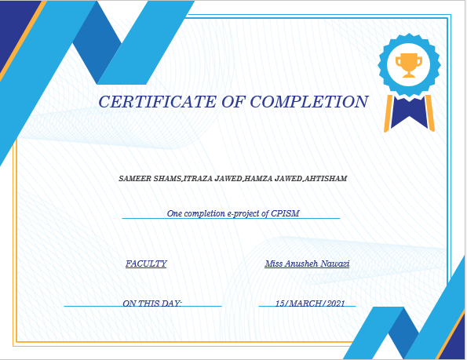

**Requirement Specification:**

The Web site is to be created based on the following requirements.

1. The home page about the description/images about various wedding planning offer should be provided. If user clicks on the same, navigational link must be available.
2. There should be categories of navbar

* + - * 1. **HOME**
        2. **ABOUT**
        3. **SERVICE**
        4. **GALLARY**
        5. **MENU**
        6. **DESING**
        7. **LOGIN**
        8. **BLOG**
        9. **CONTACT**

**Hardware/Software Requirements**

**Hardware**

* A minimum computer system that will help you access all the tools in the courses is a Pentium 166 or better
* 64 Megabytes of RAM or better

**Software**

* Notepad/HTML editor
* Visual studio code
* IE 5.0/ Netscape 6.0

**Site Map**



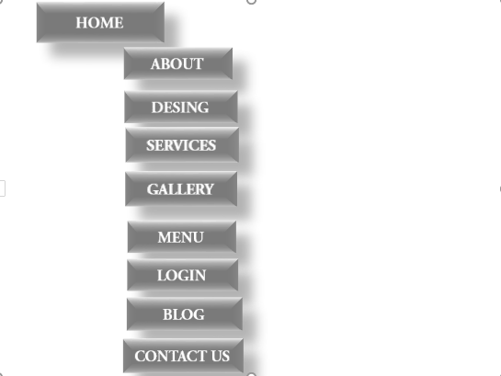

**PRELOADER**



**CONTACT US**

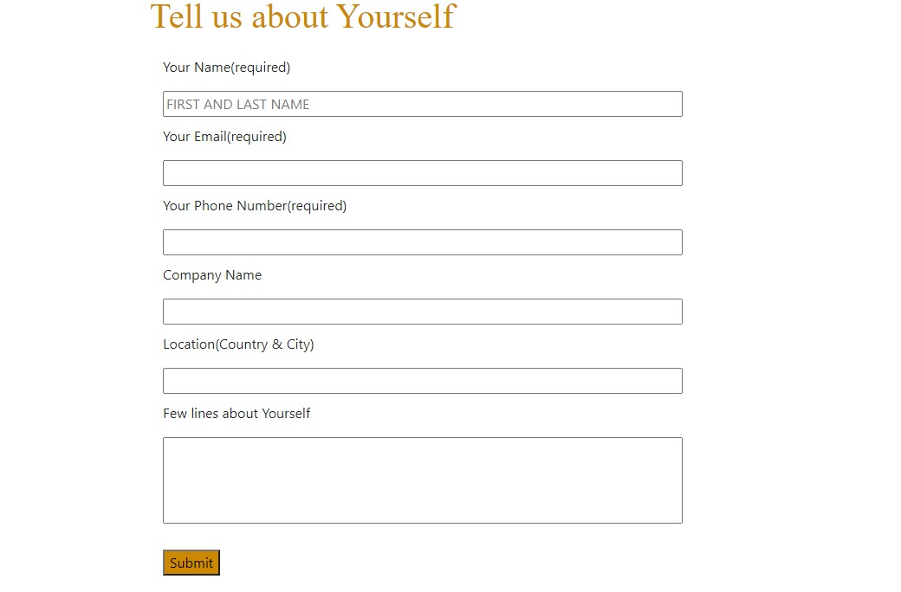

**CODING**

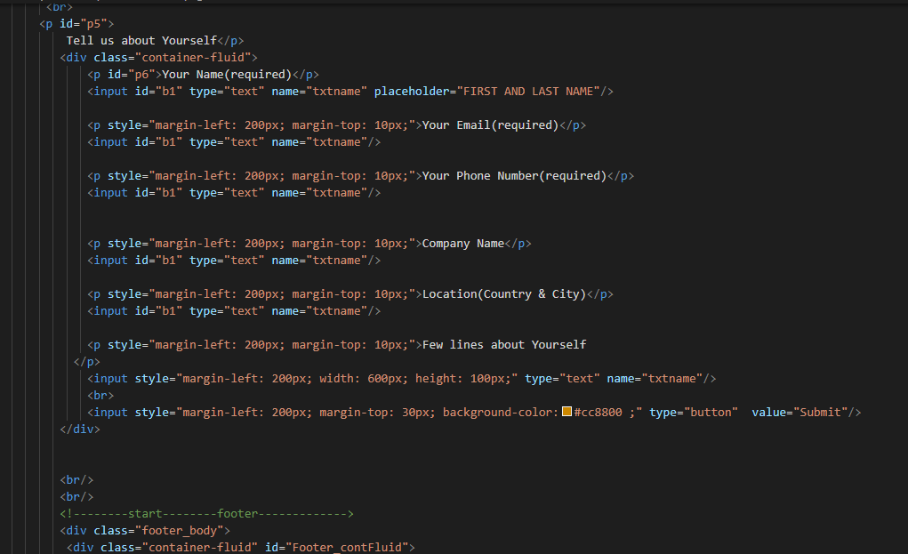

**FOOTER**

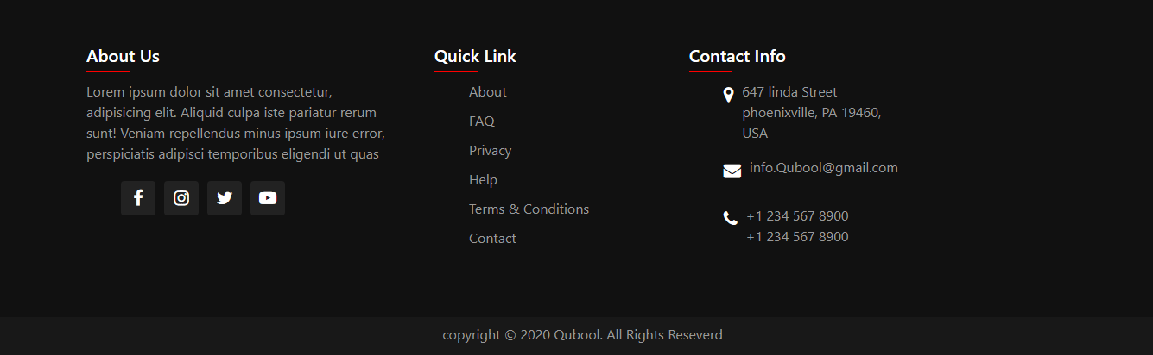

**THANK YOU**

**FROM OUR TEAM MEMBERS**

1. **HAMZA RASHID**
2. **IRTAZA JAVED**
3. **AHTISHAM TARIQ**
4. **SAMEER SHAMS**